**Name :** عمر علاء المصلحي خطاب

**B.N:** 556

**Date :** 25/5/2020

**Topic:** mobile computing

**Github link :** <https://github.com/omar-khattab1/html-project-repository>

**Github page :** <https://omar-khattab1.github.io/html-project-repository/index.html>

**Application brief :**

Mobile Computing is a technical field that covers the design, development and evaluation of mobile applications using appropriate solutions that meet user requirements. This includes learning the technology that is used to perform a wide variety of tasks on devices that are portable. Portable devices include Smart Phones, Tablets, Laptops, wearable devices, vehicles etc.

Upon completion of this specialisation, students should be able to develop mobile apps applying algorithmic and programming concepts that are cross platform beyond Android and iOS. This would help students to pursue their personal passion of developing mobile apps or to expand their job prospects as a Mobile Apps Developer, Android Developer, Mobile Technical Lead/Architect, Mobile Solutions consultant, Hybrid Mobile Application developer, Mobile Software Architect and more**.**

**Screeshots :**

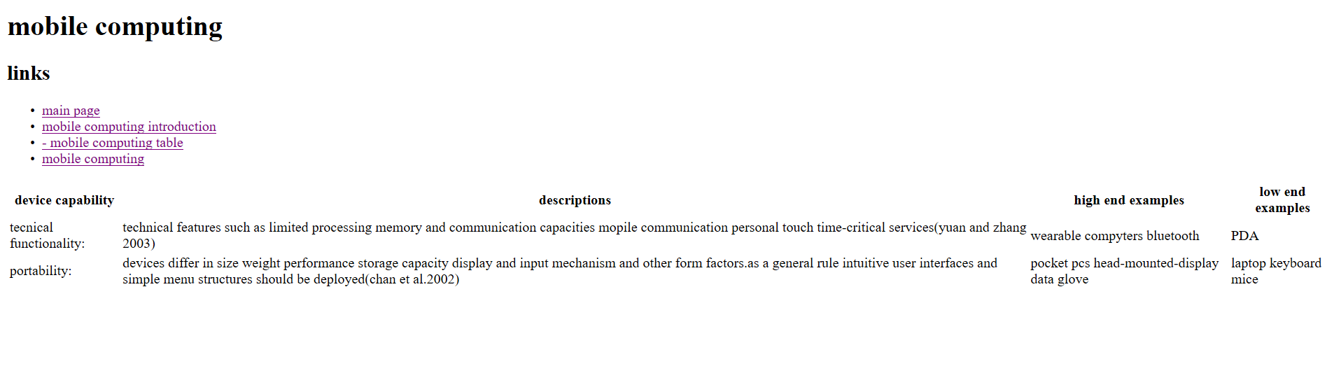

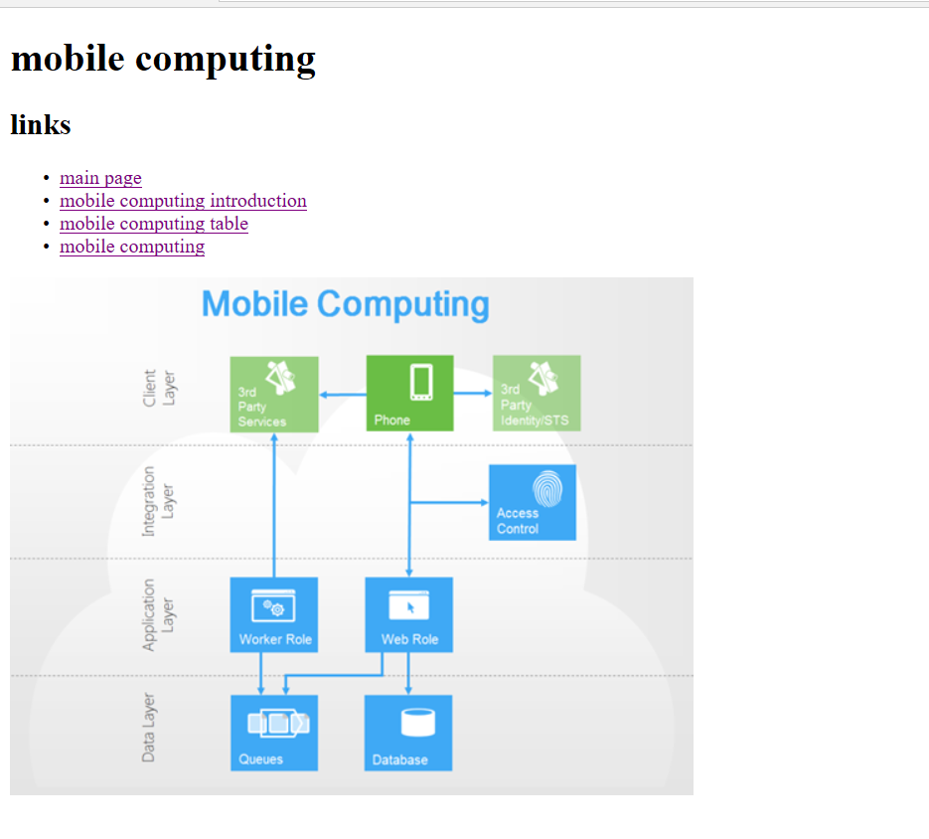

**Source code :**

